1. Provide a screenshot to show that you have successfully downloaded and extracted the Assignment22_2 folder on your local machine.

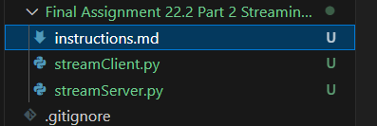

1. Provide a screenshot to show that you successfully opened the streamServer.py file in VS Code and changed the port number to 7000.

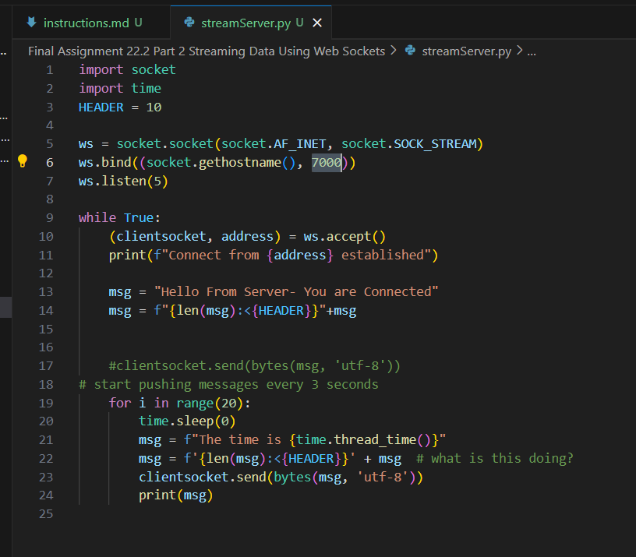

1. Provide a screenshot to show that you successfully opened the command prompt in the streamServer.py folder and ran the python streamServer.py command without errors.



1. Provide a screenshot to show that you correctly modified the code in the streamServer.py file to call the thread_time()*function* from the time *library*.

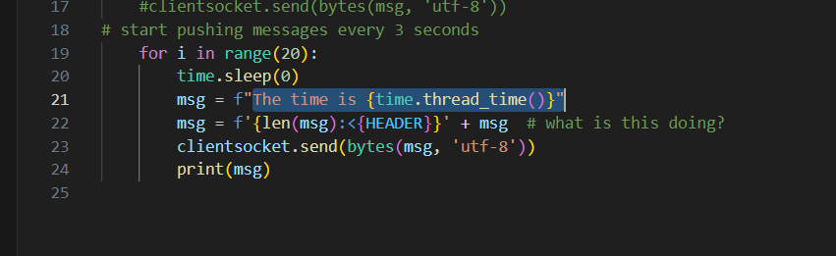

1. Provide a screenshot to show that you successfully opened the streamClient.py file in VS Code and that you changed the port correctly.

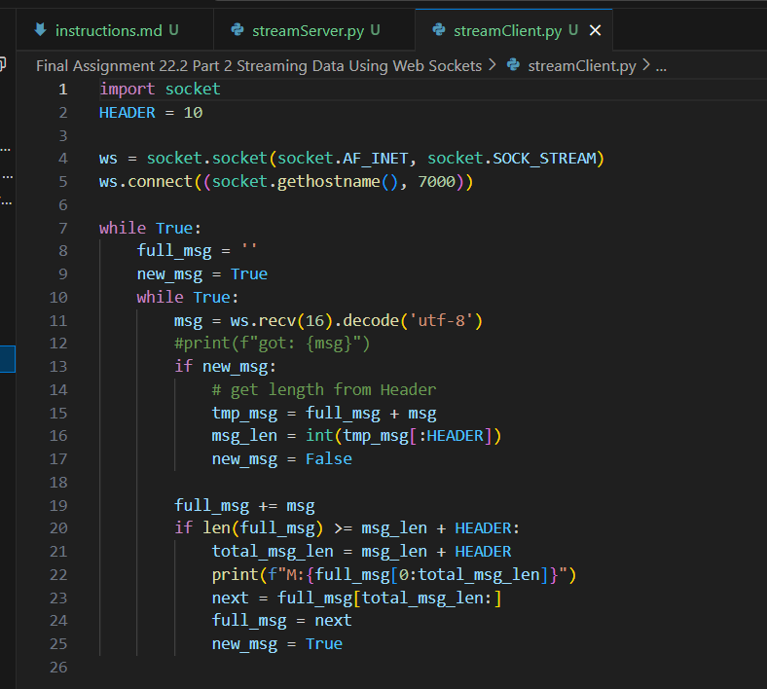

1. Provide two screenshots. The first screenshot should show that you successfully ran the streamClient.py file. The second screenshot should show that the *server* is receiving messages from the *client*.

